PRESS RELEASE FOR PUBLICATION
Leonberg, 20.10.2017

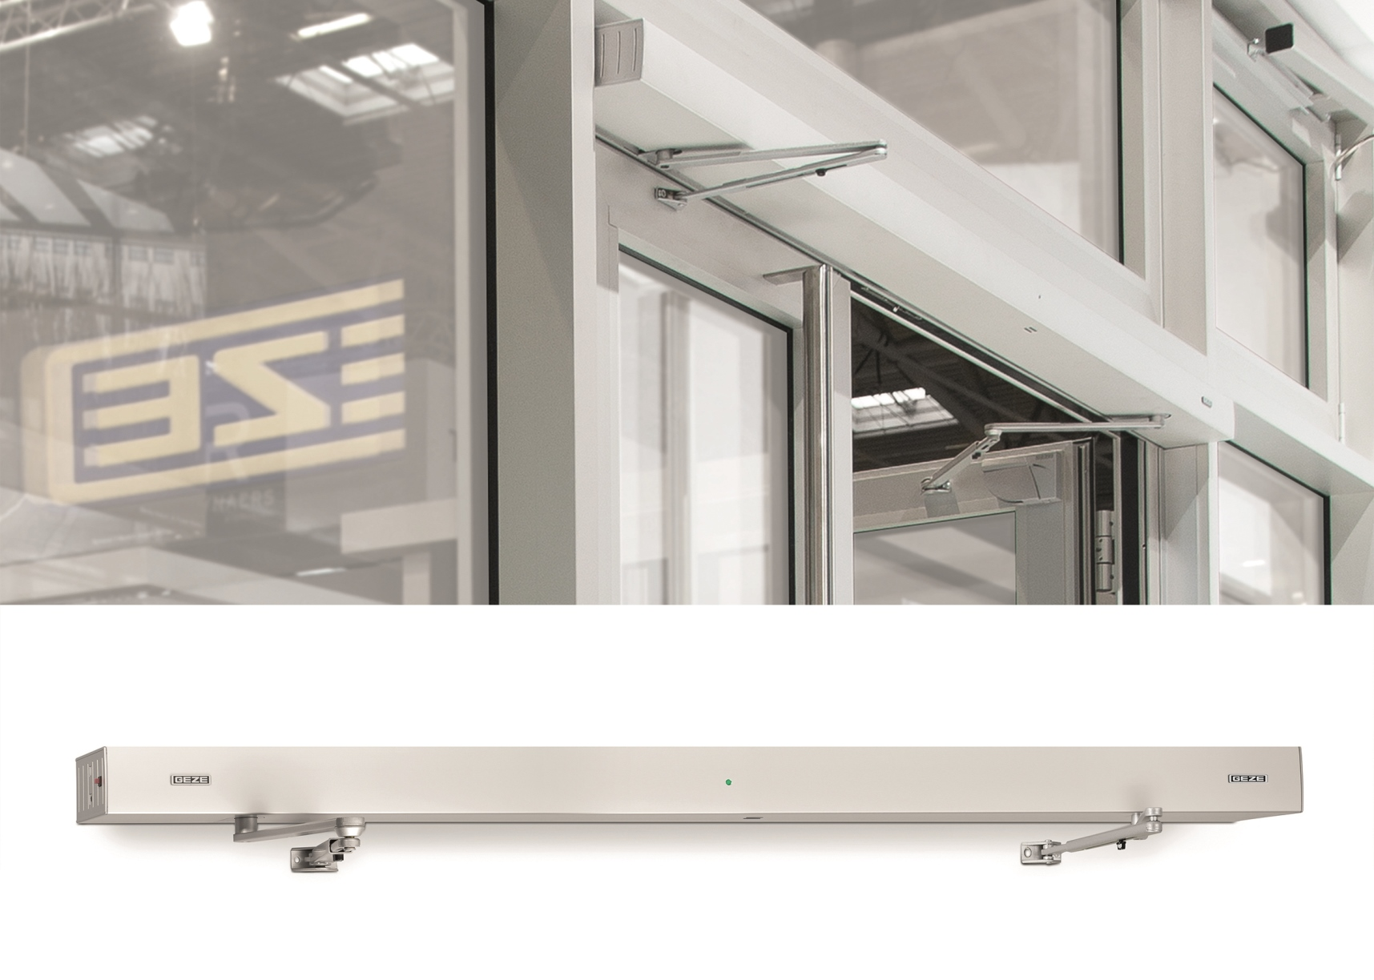
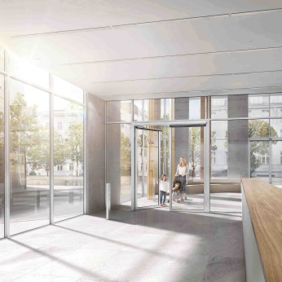

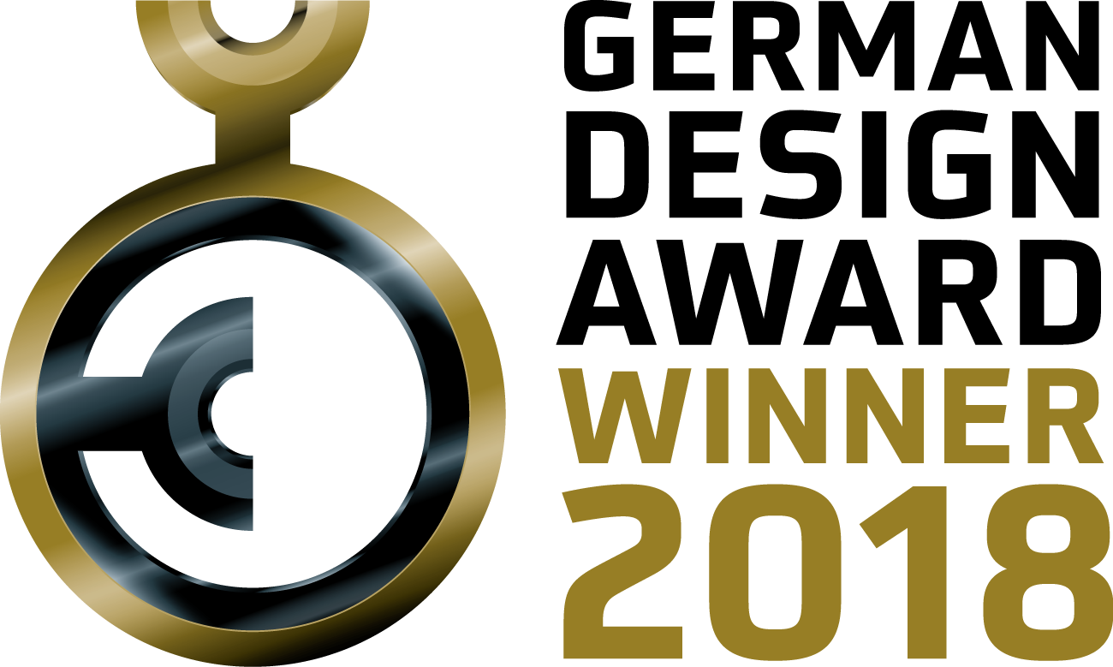

Images: GEZE GmbH

Winner of the German Design Award
Powerful GEZE design: Powerturn F-IS/TS swing door drive system receives prestigious design award

Outstanding design recognised at one of the world's most lauded design awards: the Powerturn F-IS/TS swing door drive system has been announced the winner of the German Design Award 2018. This top prize is awarded by an international panel of experts of the German Design Council.

The German Design Award is all about design quality. The best design products per category are recognised as winners of the German Design Award. The Powerturn F-IS/TS swing door drive system, a powerful connection of automatic doors and door closer technology, was awarded the coveted prize in the 'Building and Elements' category.

Design highlight: one look for two technologies
This unique combination of swing door drive and door closer is an attractive variant for double-leaf doors where mainly the active leaf is moved, and automatic operation means improved convenience. One particular visual feature is the universal drive look across both door leaves. This duo is a welcome solution on asymmetrical doors.

We've got it all covered
The active leaf is equipped with the Powerturn swing door drive. Its strengths are barrier-free convenience, a high range of functions, creative freedom and a subtle design. The Powerturn also opens large and heavy single and double-leaf doors easily and safely, on prestigious entrances or indoors. At a height of only 7 cm, the drive is suited for any installation situation, and moves door leaf weights of up to 600 kg.

The passive leaf is equipped with a door closer, e.g. from the TS 4000 or TS 5000 series, and is only opened when necessary. The drive housing also contains the closing sequence control requested for fire protection doors. It guarantees that both door leaves are correctly closed again in a controlled way after access, e.g. by fleeing persons in the case of danger. The Powerturn F/R-IS/TS swing door drive/door closer combination for hold-open systems unites innovative technology and design, as the smoke control unit is invisibly integrated into the cover.

About the competition
The German Design Award aims to discover, highlight and award unique design trends such as the design of the GEZE Powerturn F-IS/TS swing door drive system. This prestigious prize is awarded by the German Design Council, one of the world's leading centres of excellence for design communication and brand leadership. All the awards are decided during a two-day sitting by a panel made up of top-ranking design experts from every different professional direction.

Press contact:  Julia Graf  Tel.: +49 (0) 7152 203-505  j.graf@geze.com  Fax: +49 (0) 7152 203-237 | GEZE GmbH  Reinhold-Vöster-Str. 21-29  D-71229 Leonberg  www.geze.com

About GEZE
The GEZE brand stands for innovation and for top quality products, processes and services. GEZE is one of the leaders in the global market and it is a reliable partner worldwide for door, window and safety technology products and systems. No matter what the requirements of a building are – GEZE implements optimum solutions and combines functionality and security with comfort and design. GEZE door closers open up numerous technical and visual possibilities. Every day, millions of people go through doors equipped with the overhead door closers from the TS 5000 series and enjoy the comfort of automatic door systems, e.g. the Slimdrive range. Barrier free door and window systems provide greater comfort, not only for people with restricted mobility. The glass systems and fitting solutions for the attractively designed sliding systems are the ultimate in design aesthetics. GEZE also offers a wide product range in the field of window and ventilation technology. Complete "intelligent" smoke and heat extraction solutions (RWA) and a comprehensive selection of door systems for RWA air supply solutions are also available for preventive fire protection. GEZE's safety technology includes escape and rescue route solutions, lock technology, and access control systems. The GEZE building management system provides an overview of a building's entire technical facilities. With its systems expertise, GEZE creates coordinated system solutions which combine individual functional and safety requirements in one intelligent system. GEZE product solutions have received numerous awards and can be found in renowned structures all over the world. The company has a global presence with 31 subsidiaries, 27 of which are outside Germany, a flexible and highly efficient sales and service network, and almost 2,800 employees. In the 2016/2017 fiscal year, GEZE achieved a turnover of over 406 million euros. www.geze.com

